Steps to run the project:

1. Open the project in visual studio
2. Make a virtual env to run python script
3. ***python -m venv tabvenv***
4. Activate the virtual env.
5. go to tabvenv -> scripts -> and drag n drop Activate.ps1 file to vs code terminal and press enter.
6. Install the requirements.txt file using: ***pip install -r requirements.txt***
7. Run mainscript.py -> ***python mainScript.py***, while the tabenve in **activated**.
8. Open the index.html file on live server

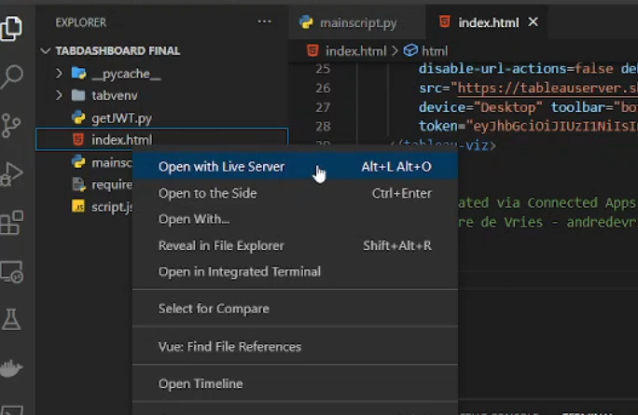

1. Browser will open, index.html